Apple IOS
Downloading an Attribute Schema (.kml file)
1. From your phone, open email with schema attachment
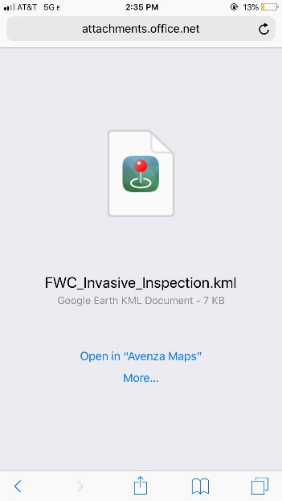
2. Tap FWC_Invasive_Inspection.kml attachment. A window will pop up that says ‘Open in “Avenza Maps”’ or ‘More…’.

3. Tap ‘More…’.
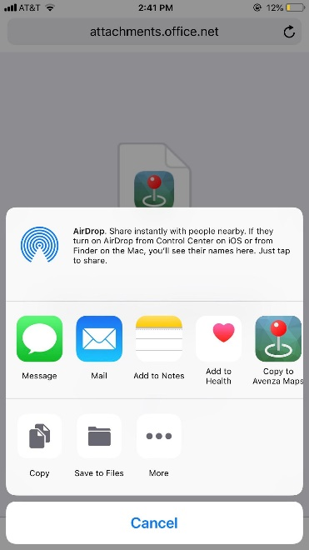
4. Select ‘Copy to Avenza Maps’

Linking an Attribute Schema
1. Open the map that you want the schema on
2. Tap on the Map Features icon (next to the wrench) (NOTE: you can also import the schema to the Layers tab and choose not to link it to a map. The remaining steps are the same for both options)
3. Tap Import Map Features (square with a downward arrow)
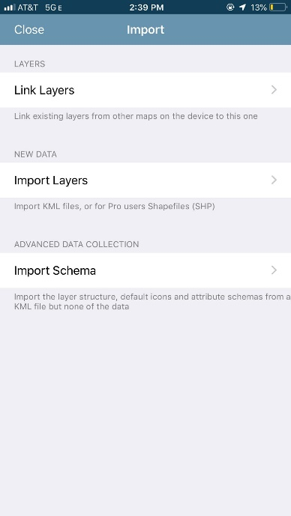
4. Tap ‘Link Layers’

5. Select ‘FWC_Invasive_Inspection’
6. Skip to section ‘Using Attribute Schemas’

Importing an Attribute Schema – only used if the schema was downloaded to your phone NOT using the ‘Downloading an Attribute Schema (.kml file)’ instructions!
To import a custom schema provided to you or that you have created, you will use a similar process to Importing Map Features:
- Open the map that you want the schema on
- Tap on the Map Features icon (next to the wrench) (NOTE: you can also import the schema to the Layers tab and choose not to link it to a map. The remaining steps are the same for both options)
- Tap Import Map Features (square with a downward arrow)
- Tap Import Schema
- Navigate to the desired file. (NOTE: the schema must be in KML format)
NOTE: Once imported, the schema will be on its own layer and may require additional changes in order to be the active layer for data collection. Please see below on how to use schemas in the app.
Using Attribute Schemas
With an active layer schema, users can begin collecting data using the pre-designed attributes, icons, any other styling settings. To collect data using a schema please follow the steps below:
- Set the schema as the active layer on a map
  - Tap the 'i' icon beside the layer from the Map Features list
  - Choose ‘Set As Active Layer’
  - Tap Back and then Close to return to the Map View
- Add a placemark to the map
- Before confirming the addition of the feature ('Submit' in the top right corner), scroll down to 'Attributes'
- In the Attributes section, tap the attribute you need to enter data for
- If the attribute has a picklist, choose the appropriate value, or enter a new value
- Tap the back arrow to return to the Add Placemark screen
- Repeat steps 4-6 for each remaining attribute
- If you are taking data for a species not on our dropdown list, you will want to go back and write the species name in the ‘Description’ field.
- Tap 'Submit' to confirm the placemark addition
- Repeat for any other features

