Using Attribute Schema with Avenza Maps
Android
A. Getting a Map in the App
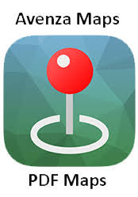
Step 1A: Download and open the Avenza Maps app.

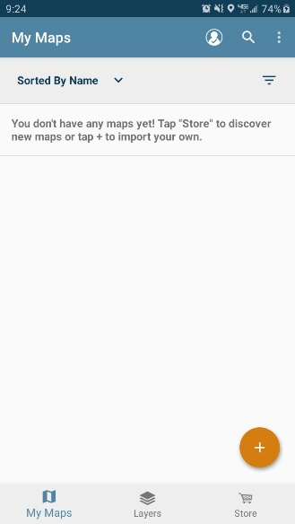
Step 2A: Tap the ‘+’ icon at the bottom right corner of your screen.

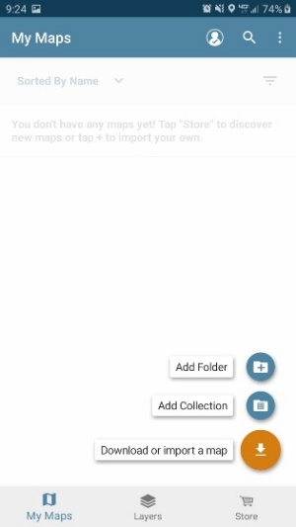
Step 3A: Tap ‘Download or import a map”.

Step 4A: Choose a location on your phone to import the map.
‘From Device Storage’ will navigate through folders stored on your phone.
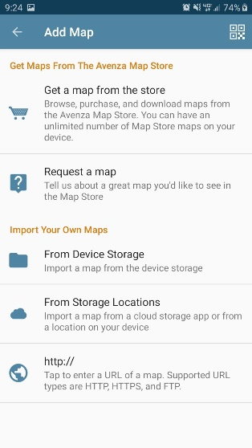
‘From Storage Locations’ will navigate through folders stored on a memory card in your phone.

Step 5A: Once you choose a map you will be brought back to the ‘My Maps’ page of the app while the map is imported.
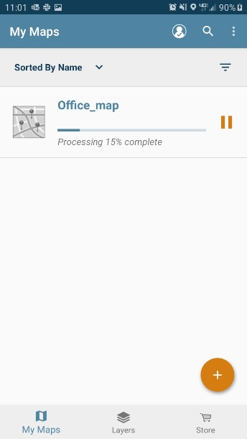
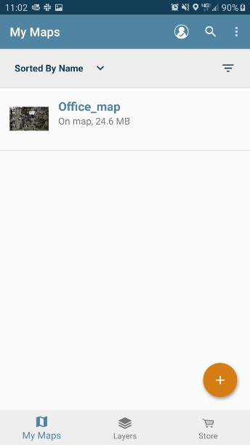
You may only utilize three maps at once in the free version of Avenza. If you have more than 3 maps imported at once only the first 3 that were imported can be active. To remove a map press and hold over the map name. An orange bar will appear at the top of the screen. Tap the garbage can icon to “delete” the map. This will NOT delete the map, nor any layers linked to that map, from your phone. “Deleting” the map will only remove it from the My Maps page but the PDF will remain in its file location on your phone or memory card.

B. Linking an Attribute Schema to your Map
Step 1B: Tap the map name you wish to use for collecting data.
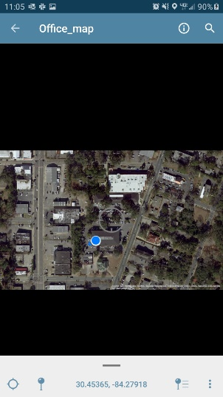
Step 2B: Tap the ‘Map Features’ icon on the bottom right of the screen. It looks like a pin next to three horizontal lines. The ‘Map Layers’ page will open.

Step 3B: Tap the orange icon with 3 horizontal lines at the bottom right of the screen. The icon will expand to show 2 icons: ‘Export Layers’ and ‘Import Layers’.

Step 4B: Tap the ‘Import Layers’ icon. The ‘Import Layers’ page will open.

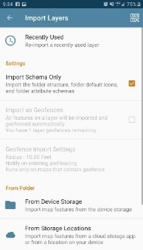
Step 5B: Tap ‘Import Schema Only’.

Step 6B: Choose ‘From Device Storage’ or ‘From Storage Locations’, depending on the location where your PDF map is stored.
‘From Device Storage’ will navigate through folders stored on your phone.
‘From Storage Locations’ will navigate through folders stored on a memory card in your phone.
Step 7B: Navigate to the attribute schema location on your phone. The attribute schema is named ‘FWC_Invasive_Inspection.kml’. Tap this kml file. The ‘Map Layers’ page will open up.

Step 8B: Press and hold ‘FWC Invasive Species Inspection’. An orange bar will appear at the top of the screen.

Step 9B: Tap the ‘Edit’ icon that looks like a pencil. This will open up the ‘Edit Layer’ page.

Step 10B: Rename the title of the layer to something unique, perhaps the project code or property name. Otherwise, you will end up with a bunch of layers on your phone named FWC Invasive Species Inspection. You will want to do this each time you do a compliance inspection.
Step 11B: Tap ‘Set To Current Layer’. It will now read ‘Current Layer’.
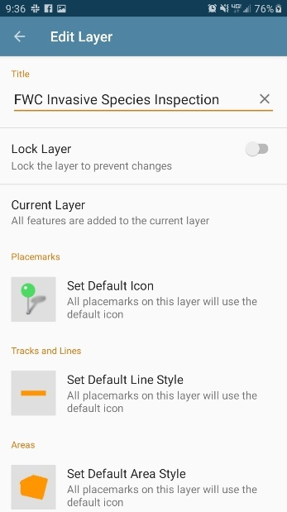
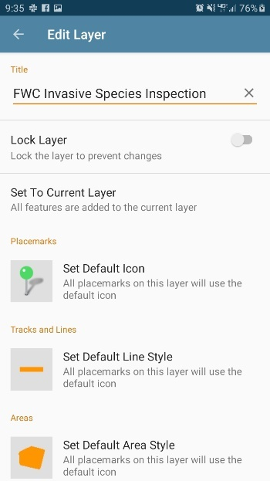
Step 12B: Press the back button on your phone or the app to return to the ‘My Maps’ screen.
Step 13B: Tap the map you wish to use to navigate and collect data. It will open up a screen showing the map you have imported. You are now ready to navigate and collect data!

C. Collecting Data
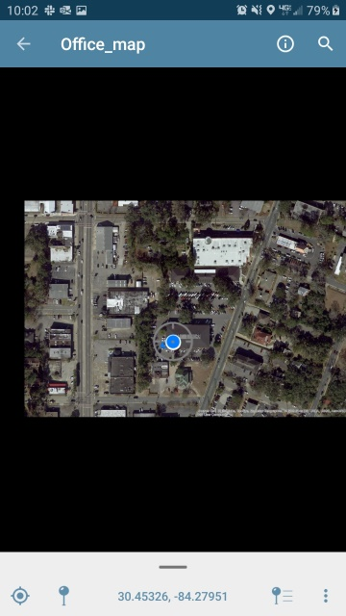
Step 1C: To drop a pin at your current location (where you are standing) first tap the ‘My Location’ icon at the bottom left of the screen. This will automatically center the ‘Target’ over the blue dot representing your current location. If this is not done, a pin will be dropped wherever on the screen the target happens to be at that moment and not where you are standing. It is best to give the app a few seconds to narrow in on your location.

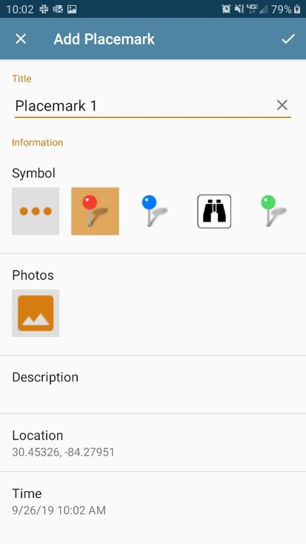
Step 2C: Now tap the pin icon second from the left at the bottom of the screen. The ‘Add Placemark’ page will open up.

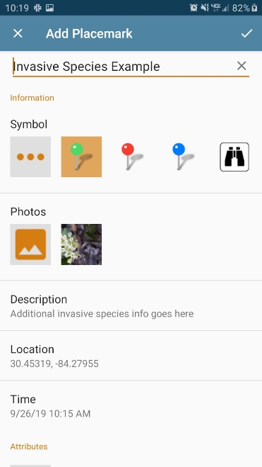
Step 3C: Name the placemark to your choosing. Choose a symbol to represent your placemark. The icon farthest left under the ‘Symbol’ heading with three dots will allow you to choose from a variety of placemark shapes and colors.

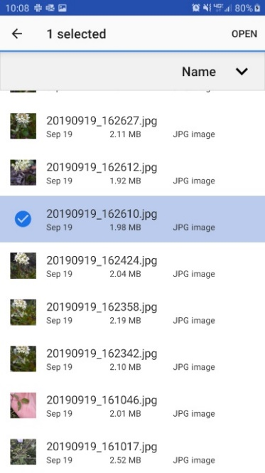
Step 4C: Click the photo icon under the ‘Photos’ heading. To take a photo tap the camera icon in the upper right corner of the screen. To choose a photo you have already taken tap the image icon in the upper right corner of the screen. Navigate to the photo location on your phone or memory card. Tap the image you would like to attach to the point. Tap the back button in the app to finish attaching the photo.

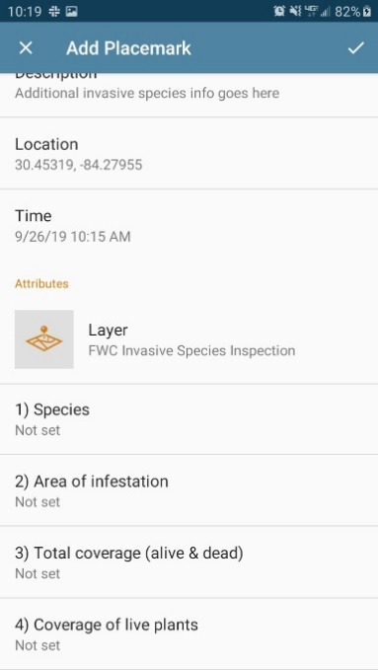
Step 5C: Scroll down to the ‘Attributes’ heading. You should see ‘Layer FWC Invasive Species Inspection’ with four data categories: 1) Species 2) Area of infestation 3) Total coverage (live & dead) 4) Coverage of live plants.

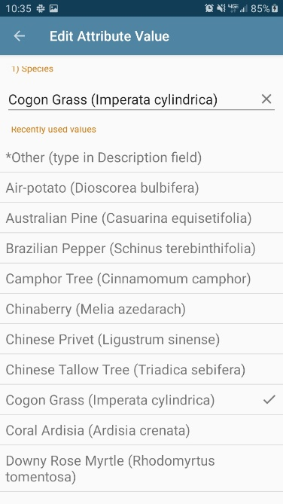
Step 6C: Tap ‘1) Species’. Invasive species are listed in alphabetical order of their common name. Common names are those used in the Florida Plant Atlas. If you do not find the species on the list tap the first selection that reads ‘*Other (type in Description field)’. Type the species name in the ‘Description’ field later. Tap the back arrow in the upper left of the screen.

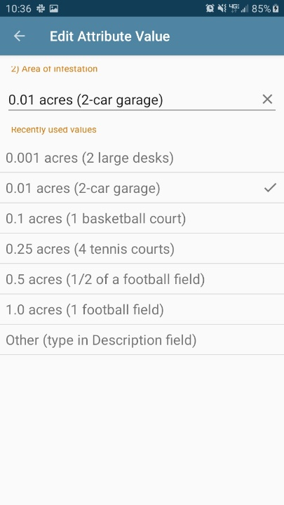
Step 7C: Tap ‘2) Area of infestation’. There are 6 common acreages with examples of common items that roughly represent the same size area. For example, a football field is approximately 1.0 acres. ‘Area of infestation’ is intended to represent the area of live and dead plants combined. Use the minimum size area needed to represent your observation. For example, if the plants cover an area the size of a bathroom then you should select ‘0.01 acres (2-car garage)’ despite that area selected being larger than the area observed. Tap the back arrow in the upper left of the screen.

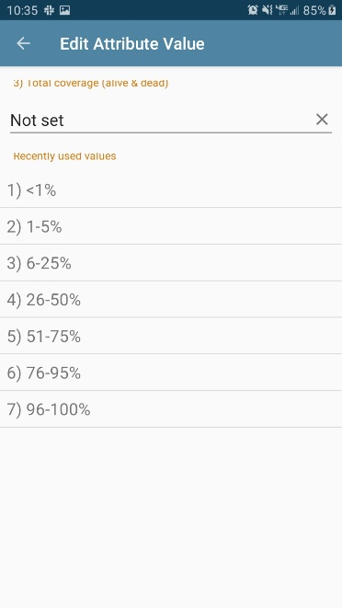
Step 8C: Tap ‘3) Total coverage (alive & dead)’. Select one of the seven standardized cover classes. The total coverage represents what percentage of the chosen area is infested. Imagine looking down at the ground from the air and assess how much of the ground is blocked by invasive plant material for the species chosen. For example, if just over half of the ground in the chosen 2-car garage area is covered by that species, choose ‘6) 51-75%’. Tap the back arrow in the upper left of the screen. If conducting a compliance inspection, this is equivalent to the cover class of the invasive species before treatment by contractors (pre-treatment coverage) at this particular location.

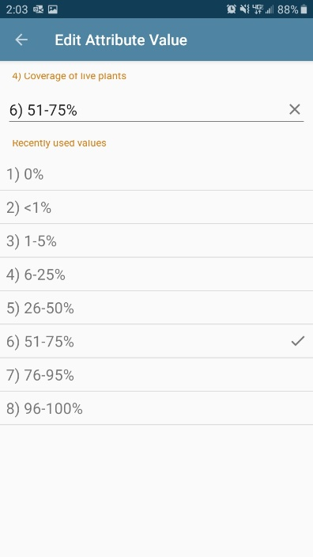
Step 9C: Tap ‘4) Coverage of live plants’. Select one of the 8 standardized cover classes. If all plants are effectively treated select ‘1) 0%’. If no plants were effectively treated choose the same cover class used in the last step. Do not choose a value larger than what you started with. Tap the back arrow in the upper left of the screen.

Step 10C: Add any additional information, such as other species or other area of infestation, in the ‘Description’ field.

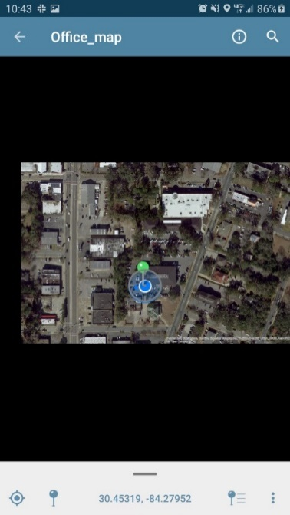
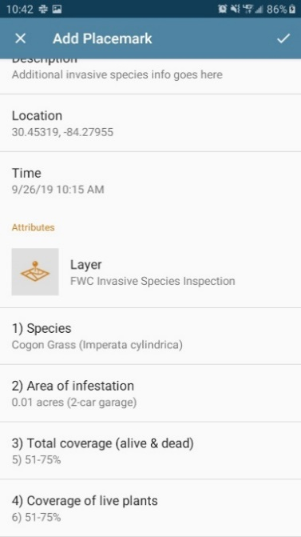
Step 11C: Tap the check mark in the upper right corner of the screen to finalize the placemark. You will be brought back to the map page with a placemark now on the map with the needle end over the blue dot representing your current location. Do not touch the pin from this moment on because you will be manually moving the location! You have now taken your first invasive species compliance inspection data point, congratulations!
Continue to the instructions for exporting data.

